Are Black Americans Stupid?
By: Tommy “Tj” Sotomayor
So while on facebook today, a lot of people kept asking me to give my opinions on an article that they were saying pretty much agrees with my stance on blacks in America! After reading it, I must say that the author made some good points. I am happy everytime a black man or woman wakes up to the reality of what is going on around them so I take no credit I only watch with joy and hope that the message keeps spreading!
I will be writing a reply article to this but in the mean time please read this and tell me what you think of what is said!~T,S.
Posted on April 17, 2014 by maxillio in Inspiration
I have been out of America for years, now. I can honestly say that when you leave American society, your mind and emotions began to heal. Your actions and thoughts begin to correct themselves. When you don’t watch the bs on TV, eat fast food, or listen to brain dead music on the radio, slowly, your “negro” programming wears off. Your taste buds change. Even the smell of your skin.
I met a rasta a few years ago at a bar. We sat for a while, had a few drinks, and in the middle of the conversation, he told me that I had the mind of a white man.
What the hell!?
I’m the most militant, pro-black person I know. How could he say that? I was offended. Years later, I understand what he meant. Before I get into that, let’s talk about MOST black people in America.
Niggas love being niggas, So much so, that they strive to be REAL niggas. They take pride in saying,”I am a real nigga”. Really? That was your goal in life? To be a real nigga?

Well, it was mine. In fact it, I took pride in knowing my friends considered me a real nigga. Ok, before some “real niggas” go into an explanation of what they think the term means for them in 2014, think about what you are saying.
You are calling yourself a nigga. You are proud of it, and making excuses for doing so. Also, before some other smart nigga tells me it means Negus, please. Stop. I know all about that, and that is not how it is used by people, today. Let’s not make excuses. There is no excuse for calling yourself a nigga. Speaking of excuses, I will explain the need for black Americans to constantly make excuses for stupidity, in a minute.
If you have no problem with referring to yourself a nigga, then you have no problem referring to your woman as a bitch. Now, before some real bitches go into an explanation of what they think the term bitch means for them in 2014, think about what you are saying. You are classifying yourself as a bitch, a female dog, and you are proud of it. Slave masters called black women bitches, because we were bred like dogs and animals. Think about what you are calling yourself. There is no excuse for that.
Why are black Americans proud to be referred to with derogatory terms? That’s stupid.
I have a woman that I see from time to time that is Haitian. She works hard and lives modestly. The money she makes goes to her children and family. I doubt that the most expensive thing she wears cost more than $50. She takes care of herself and her appearance is always immaculate. Her salary is 10 times more than the average Haitian, yet her purse, shoes, and clothes look like they came from a thrift shop. But when we go out to dinner and she pulls out all the money she has in that ugly cheap ass purse, it’s beautiful.
I have found that most non Americanized black women are more concerned with character than money and appearance.
Most black American women will live in the projects, but wear the most expensive clothes they can buy. Hair done. Nails did…as they say. Eye brows arched.Why? You live in the damn projects. Your priority should be saving your money to move OUT of the damn projects, not looking fresh in the club to impress some other broke people…who live in the projects. Thats stupid.
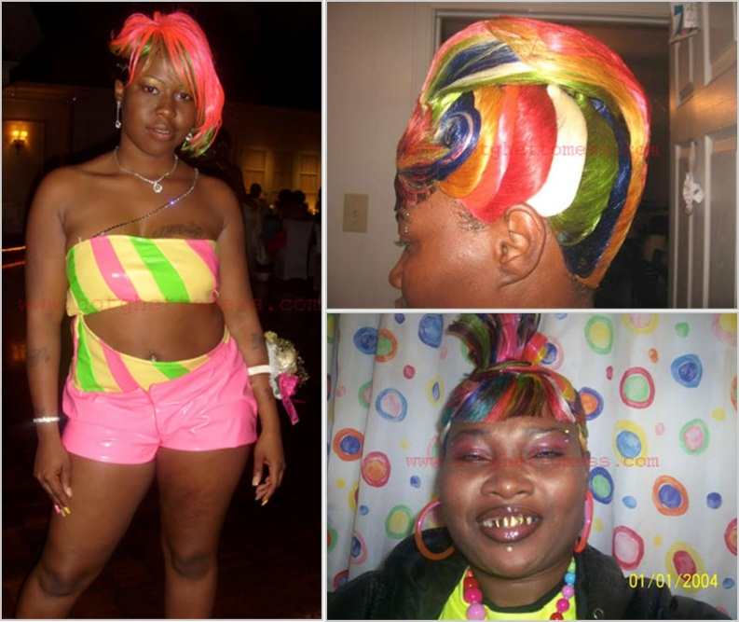
I met this woman at a club in DC. In the club she was beautiful. A week later I invited her out to dinner. When I walked into her house, I rebuked it in the name of Jesus. It was filthy! Yet, her clothes were expensive. Think about those priorities.
And by the way, weaves stink. Most men will not tell you that, but that shit smells horrible.
Black men will brag about having sex with a lot of women. I used to do that. I thought it was a symbol of manhood. I was stupid. There is nothing cool about that. It is a mentally that has been carried over from the slavery days. A young black buck was praised for how many women he could impregnate for massa. We are still impregnating our women for massa.
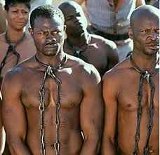
When you get a black woman pregnant, and leave her to raise the child alone, you are doing exactly what they want you to do. That child will grow up to feed the private prison system, the pharmaceutical companies by issuing him drugs to control his behavior, or he will join the army, and fight and die in wars that have nothing to do with him or his liberation.
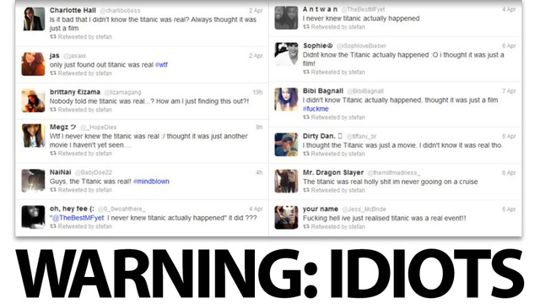
I use social media as little as possible. One reason is, I can’t deal with stupid people. If you subscribe to the Kaperville Twitter account you will see that it has cobwebs on it. I am lucky to have someone else handle our Facebook page, but from time to time, I go on there and I see the dumb shit black Americans post.
Listen, you do realise that those pictures are stored forever, right? You do realise that when you post your bare ass, or send pictures of your dick hanging out they can track it right back to you, right? Of course you dont. If you do, and you still do it, then you are stupid, and that’s the point I’m trying to make. Thanks.
Black Americans love posting their fat stankin asses, and their ashy dicks online for the world to see, and have no shame about it. They crave attention, and will jump on you, and call YOU stupid for pointing it out. See how stupid that is?
Why do black people make excuses for their lack of action? This is to the so-called conscience black community. I was reading a conversation Ms. Kaperville was having, and the person kept mentioning that the problem with the “black community” was that we were not coming together “as a people”. Ms Kaperville told the person to not worry what the black community was doing, and to just do the right thing for himself.
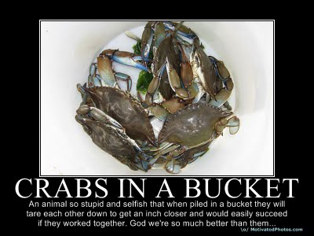
The person came back with excuse after excuse for not taking action. I don’t think black people really want to do anything. I think they enjoy TALKING about doing something, but when it comes down to action, they seem to always be waiting for someone else to lead them, or go first.
Black Americans like to “one up” each other. You know where that comes from? The crab mentality. No one accomplishes anything, because everyone is trying to one up each other. That’s stupid.
The cycle of ignorance. You hear me mention that all the time. Black Americans seem to be locked in a self-sustaining cycle of stupidity. Women post pictures of their flabby asses online, because dumb thirsty men will give them attention, and dumb thirsty men give them attention because they are posting their stankin’ asses online. See how that works? It’s like a renewable energy source of ignorance.
Black Americans love talking. Thats all they do. Talk. Oh! And march. Do you see how those white people in Nevada came together and stopped the government from taking that rancher’s cattle? Yeah. That was some real organisation. That was real action. If it had been a black person, Al Sharpton would have showed up and black Americans would have been marching around the desert singing “We Shall Overcome”. Black Americans settle. They love the illusion of action. They love to say they are a part of “something”. That “something” does not actually have to be accomplishing anything, just as long as it has a logo and a slogan, they are fine.
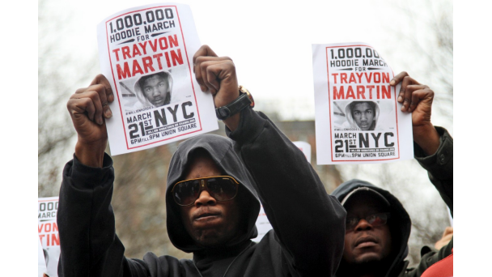
Look at the Trayvon Martin murder. Zimmerman is free. Walking around and signing autographs. No one is marching for Trayvon, anymore. You wanna know why? Because Black Americans didn’t care in the first place. It was just some shit to do, and black men only kill each other. They will kill you for stepping on their shoes, but Zimmerman is still walking around.They should have burned that courthouse to the ground, dragged Zimmerman to the nearest tree, and…nah. That would have actually been doing something. That would have been making a real statement. Marching and wearing hoodies is much easier.
The fact that Black Americans got the chance to march was good enough for them. Not for those people in Nevada. They wanted justice and they were not leaving until they got it. Black Americans don’t have that kind of resolve, and the government knows it. We settle. We make deals. We hold conferences, and rallies, and at the end of the day, all we ask for is to be equal. Give me a break.
How can you ask for equality from a system that has shown you time and time again it does not give a damn about you? That’s stupid.
Are black Americans stupid? Only a stupid person would let his enslaver teach their children. Only a stupid person would join the military of the same people that enslaved them. Only a stupid person would follow the religion of a people that used that same religion to justify enslaving them. Only a stupid person prays to a God that looks like the people that enslaved them.
Only a stupid person would beg to be considered equal to a people who has shown they have no compassion for human life, the poor, children, prisoners, drug addicts, other cultures, women, sovereign nations, the environment, and so on. Why would I want to be considered equal to them? If anything, I would fight to NOT be considered equal to them. But not black Americans. They fight and march to take on his values, go to his schools, eat at his restaurants, beg to be apart of his sytem, fight for his causes, and promote his agendas like Planned Parenthood, even to their own detriment.
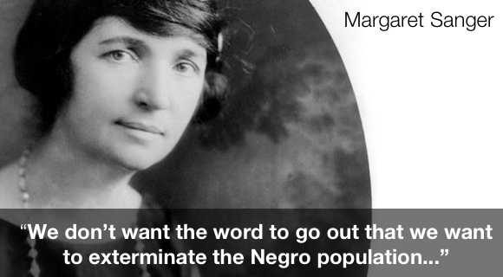
Are black Americans stupid? We glorify killing each other in our music, and it sells millions of copies. How stupid does a people have to be to love music that glorifies death and violence? How STUPID do you have to be to enjoy songs about people selling drugs? Do you see how stupid that is?
Are black Americans stupid? We know pork, fried food, fast food, and soft drinks are bad for us, but eff it. We’ll eat it anyway…AND WE KNOW IT’S KILLING US!
Are niggas stupid? I can say niggas now because, niggas don’t read. I can say anything I want, and don’t have to worry about offending them. Niggas scrolled through, and looked at the pictures. I could have put the cure for cancer in this article, and niggas would never know it.
But seriously. Niggas don’t read. Unless it is about sports, religion, or celebrities.
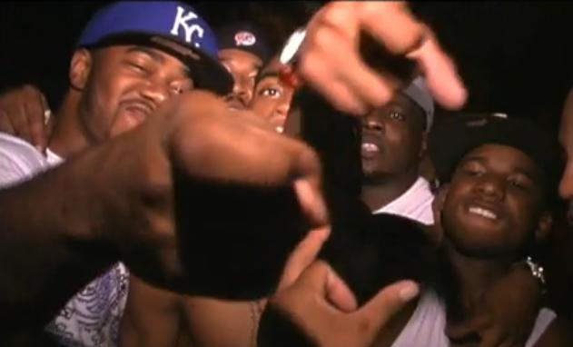
I did not write this to offend you, but to make you think. I have to say that because black Americans are emotional, and have a need to refute, debunk, debate, and counter everything you say.
Well, refute this.
Black Americans complain about living in a police state and injustice, but what are they doing about it, besides marching, praying, holding rallies, and joining groups that have never done a damn thing for them?
Hold on. That was way too complicated. Black Americans will start making excuses about us coming together “as a people” before anything can change.
Let me try it this way.
YOU complain about living in a police state and injustice, What are YOU doing about it besides talking, marching, praying, etcetera? What are YOU doing to make sure your children get a real education? What are YOU doing to make sure your family eats real food and not this GMO garbage? What are YOU doing about crime in your neighborhoods, besides waiting on the police thugs to come in and do something about it?
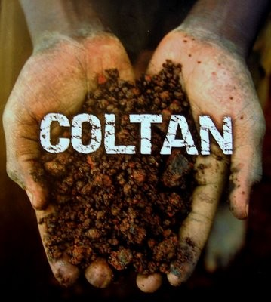
Here is something you can do, right now.
DID YOU KNOW, IF YOU BOYCOTTED APPLE YOU WOULD BE SAVING THE LIVES OF THOUSANDS OF ENSLAVED AFRICAN PEOPLE IN THE CONGO? THEY WORK LIKE SLAVES TO MINE COLTAN USED TO MAKE YOUR iPHONE. ARE YOU REALLY DOWN FOR THE REVOLUTION, OR ARE YOU JUST IN THE WAY? CAN YOU PUT DOWN YOUR PHONE TO HELP THESE PEOPLE GAIN FREEDOM?
Black people make excuses because that is the easiest way to justify not doing anything. Until we run out of excuses, nothing will happen.
If YOU aren’t going to do anything, then stop complaining. Only stupid people do that.

19
inShare

This post has no tag

